

| IRON WHEELS
Iron is involved in many metabolic processes, particularly enzymes, and as a result, many clinical manifestations, including anemia, can develop as a result of iron deficiency. While anemia is of course the most recognized condition related to iron deficiency, other conditions, such as; sideropenia can contribute to disturbances in immuno-modulation, endocrine, physical and even emotional disorders. Iron excess or toxicity can be found at the opposite end of the iron status spectrum, and can be specifically addressed by providing nutrients that are antagonistic to iron.

The following graphics illustrate some of iron’s biological antagonistic relationships (arrows indicate antagonistic effect). In the case of iron toxicity, increased intake of these antagonistic vitamins and the nutritional minerals may be of benefit. However, prolonged intake of these specific vitamins and/or minerals, singularly or in combination, can contribute to an iron deficiency, especially if the nutritional or tissue iron status is already marginal. Conversely, iron toxicity or prolonged intake of iron can antagonize these same vitamins, minerals and heavy metals. It should be noted that antagonism with another nutrient can occur via competition on an absorptive level (intestinal absorption) or metabolic level (cellular), producing compartmental displacement, or increasing requirements.
-------------------------------------------------------------------------------------------------------------------------------------------------------

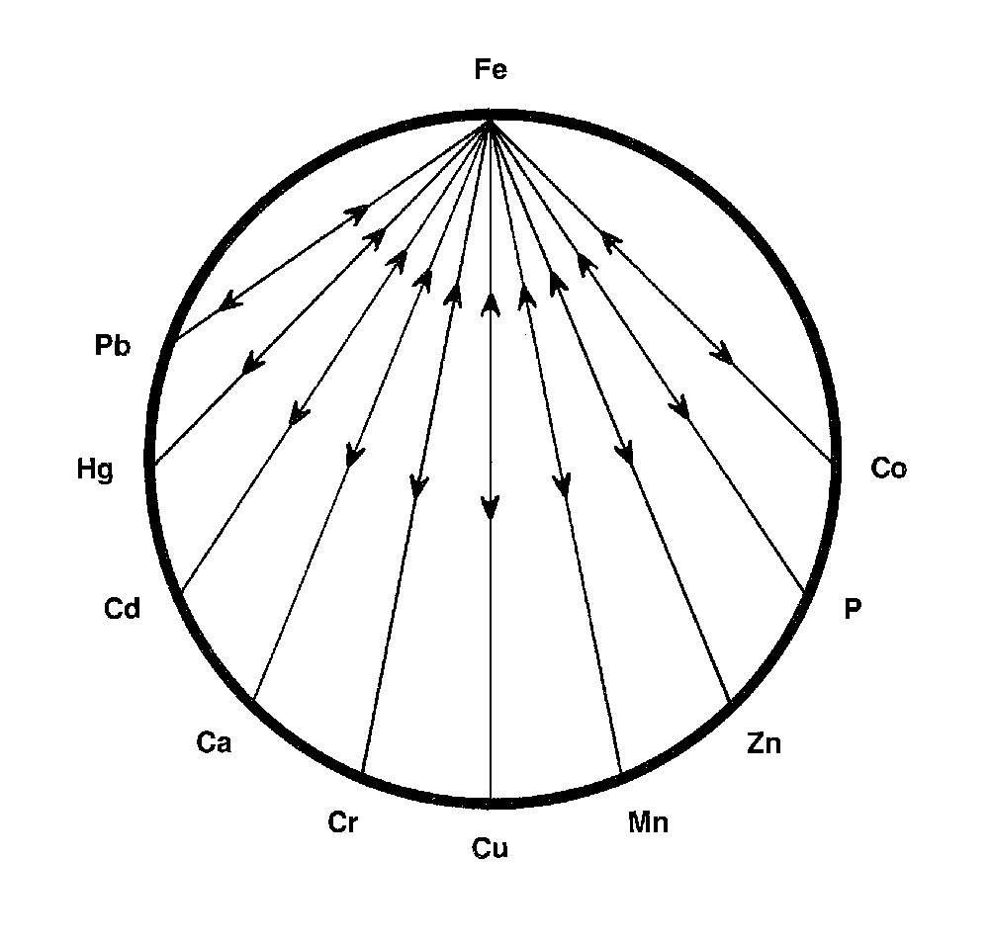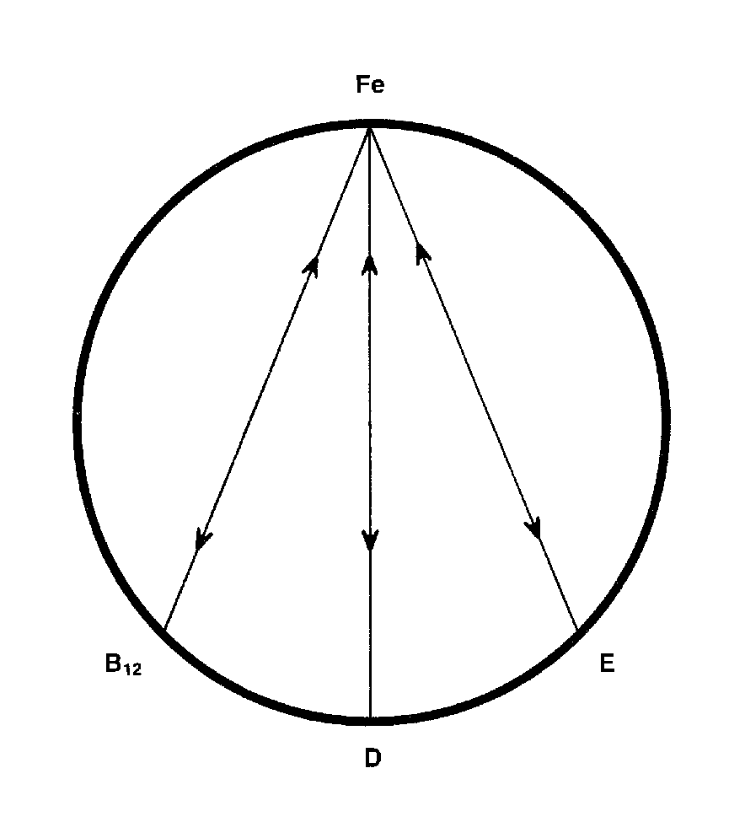
-------------------------------------------------------------------------------------------------------------------------------------------------------
For Further Information, please refer to "The Nutritional Relationships of Iron, Watts, D.L., Journal Of Orthomolecular Medicine, 3, 3, 1988
Trace Elements has pioneered the recognition of nutritional interrelationships, and specializes in evaluating individual nutritional requirements through hair tissue mineral profiles.

Copyright 1988 | Trace Elements, Inc. | All rights reserved.
No part of this document may be used or reproduced in any manner whatsoever without the express written permission of Trace Elements, Incorporated. 4501 Sunbelt Drive, Addison, Texas 75001 USA (972) 250-6410.

